**Sri Lankan Wildlife Website Project Report**

Learning experience:

* This project gave me the opportunity to put into practice every concept and designing feature I learnt in HTML and CSS. I discovered how crucial it is to properly organise web content in order to build an interface that is user-friendly. Understanding the essentials of responsive design was vital for ensuring the website's compatibility with a range of devices and improving accessibility for a larger user base. I encountered numerous challenges and learned a lot while using HTML and CSS to create a wildlife website.

Challenges and overcoming challenges:

* Faced difficulties creating the navigation bar for each page- watched Youtube tutorials and incorporated other learned concepts like flex to create a decent bar.
* Trying to resize every image without losing the quality of the image significantly.- Used the Squoosh website to resize images with lossless compression.
* Making sure the CSS styling fit all size ranges within the media query for both mobiles and desktops. And changing certain styling to adapt accordingly. For instance , using flex box on desktop and not using it on mobile. - . Adopting a mobile-first approach from the outset facilitated a smoother responsive design implementation.
* Maintaining a consistent look for the first 5 webpages. – testing each page numerous times side by side to remove any inconsistencies to ensure the webpage designs are related to each other.
* Creating simple animations for the Yala and Wilpattu webpages- watched Youtube videos on how to create subtle animations using CSS only.

**WIREFRAMES- DESKTOP DESIGN**

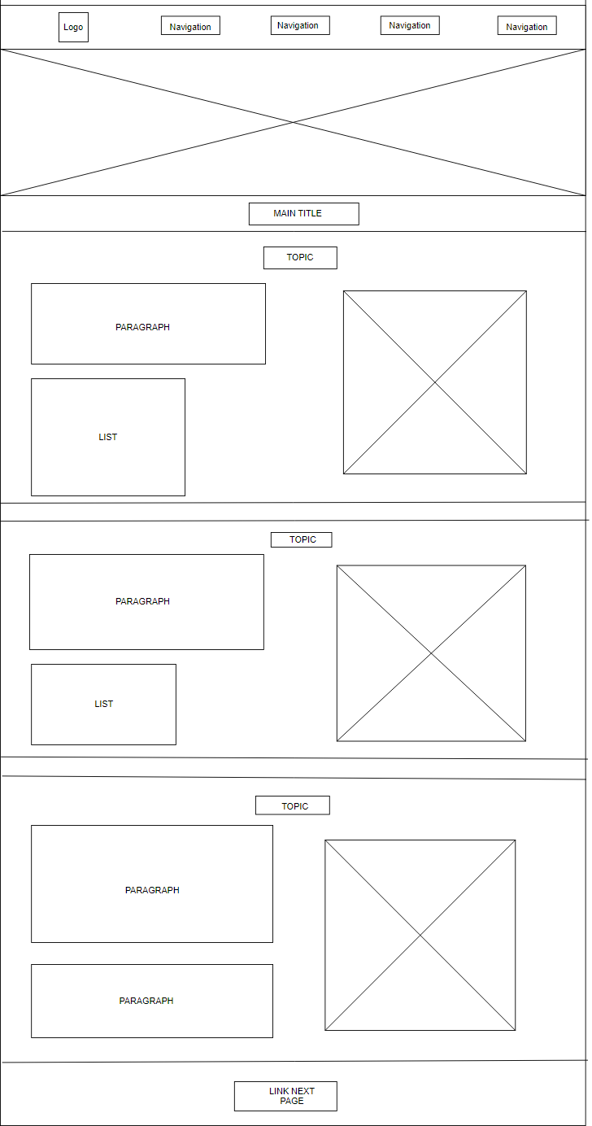

PAGE 1

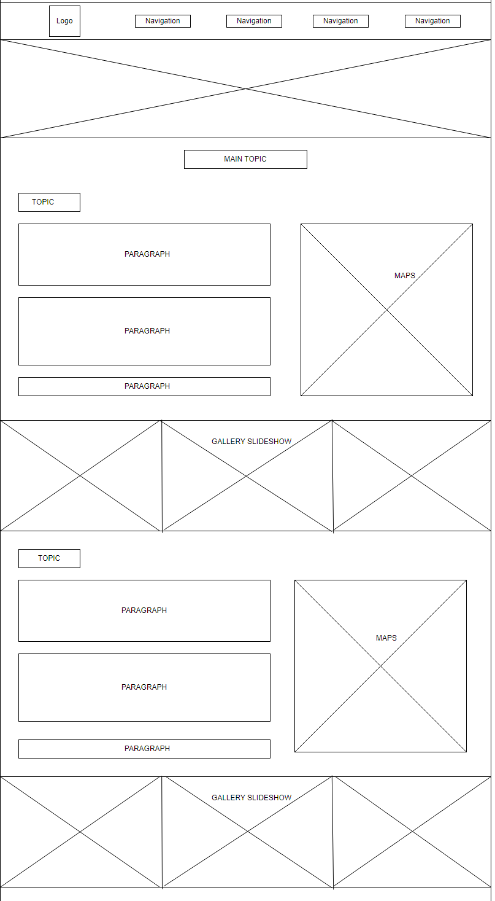

PAGE 2

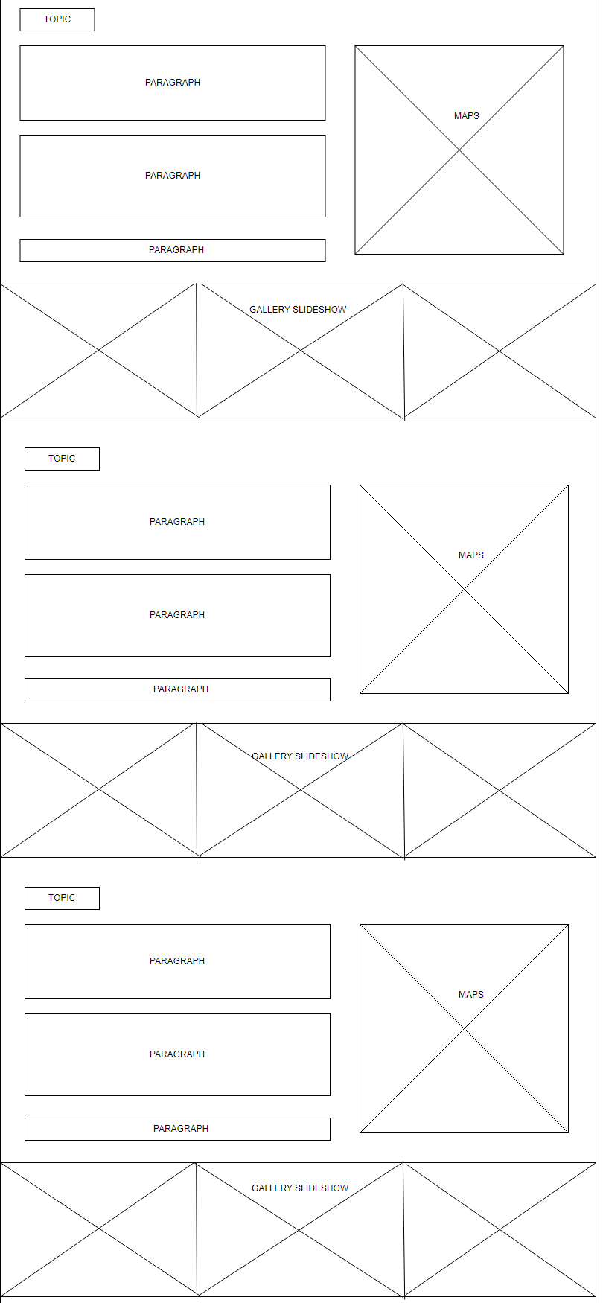

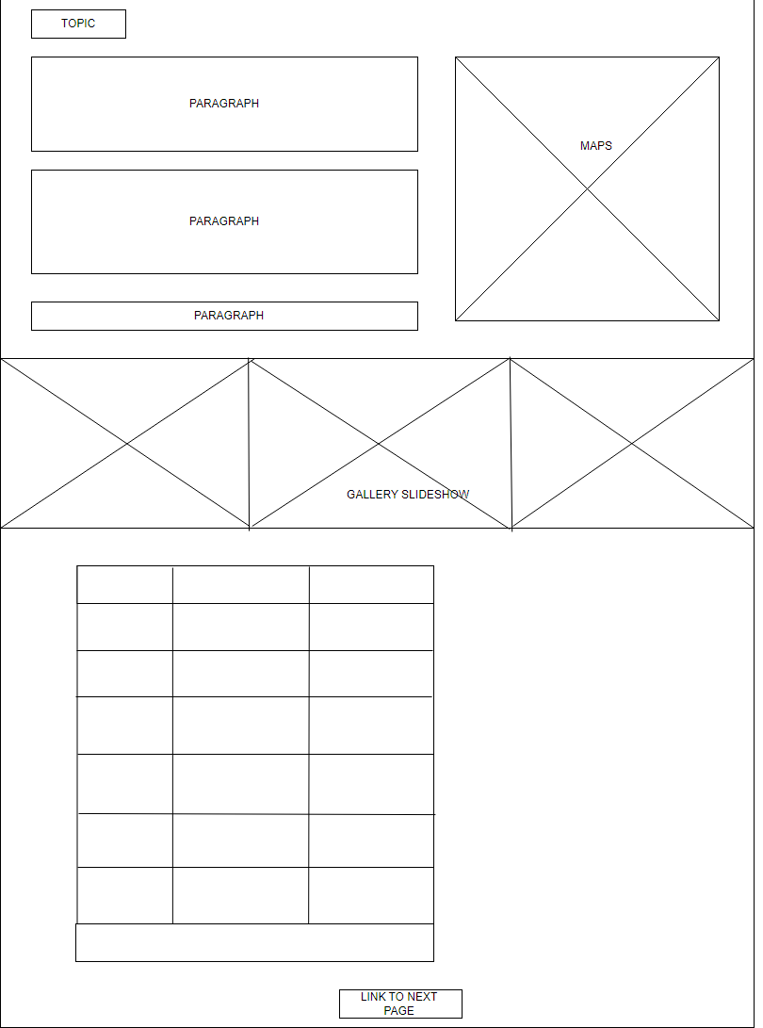

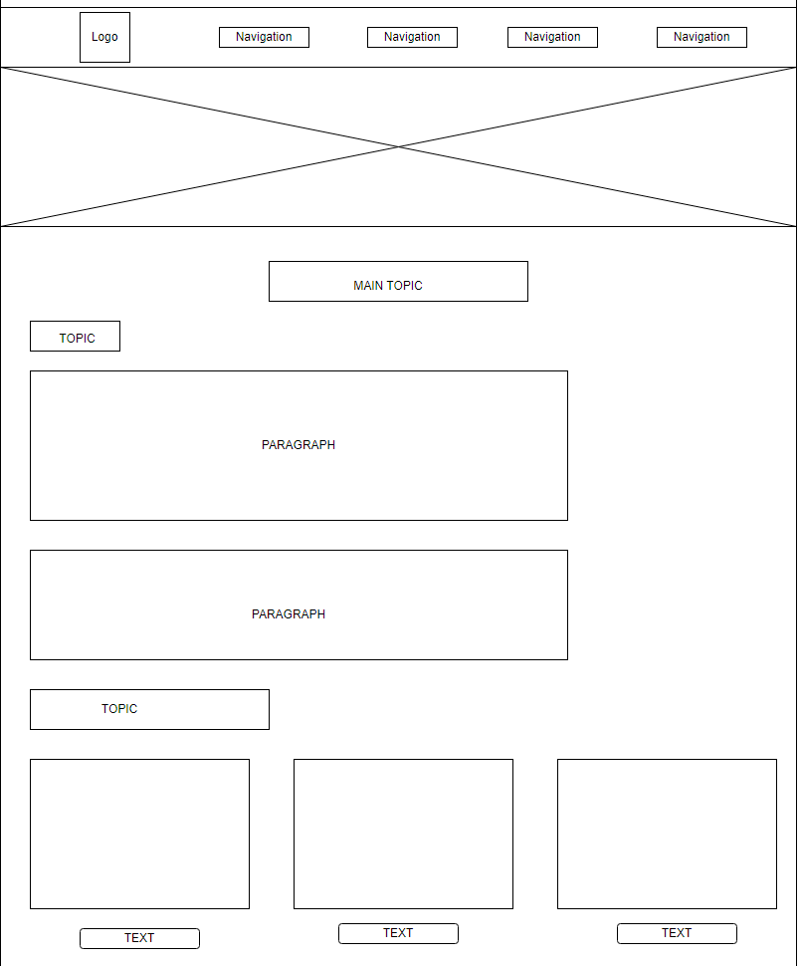

PAGE 3

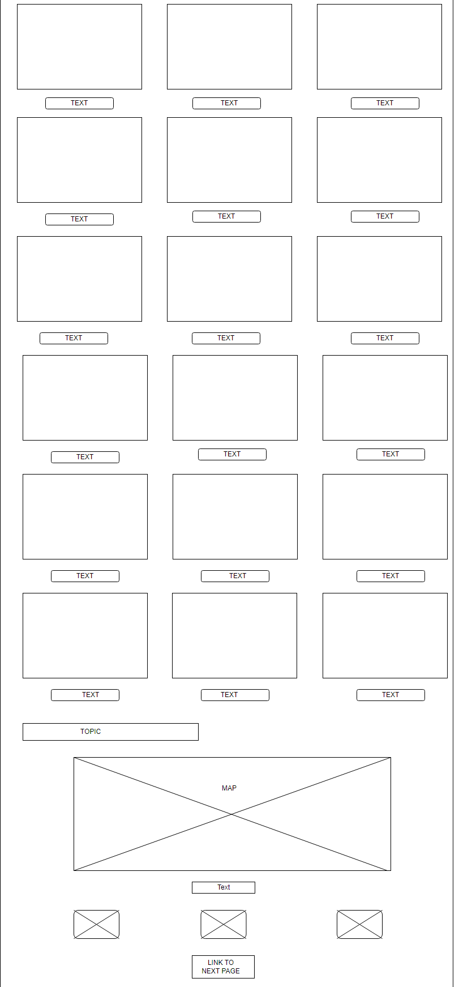

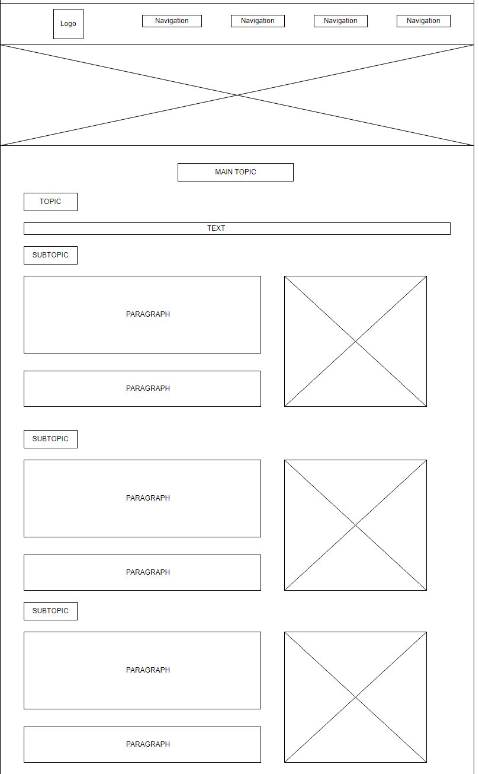

PAGE 4

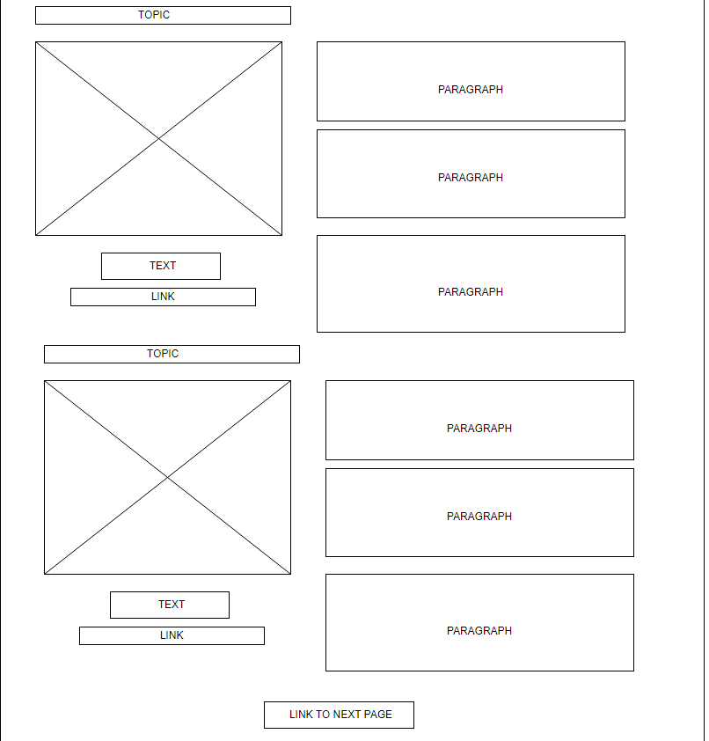

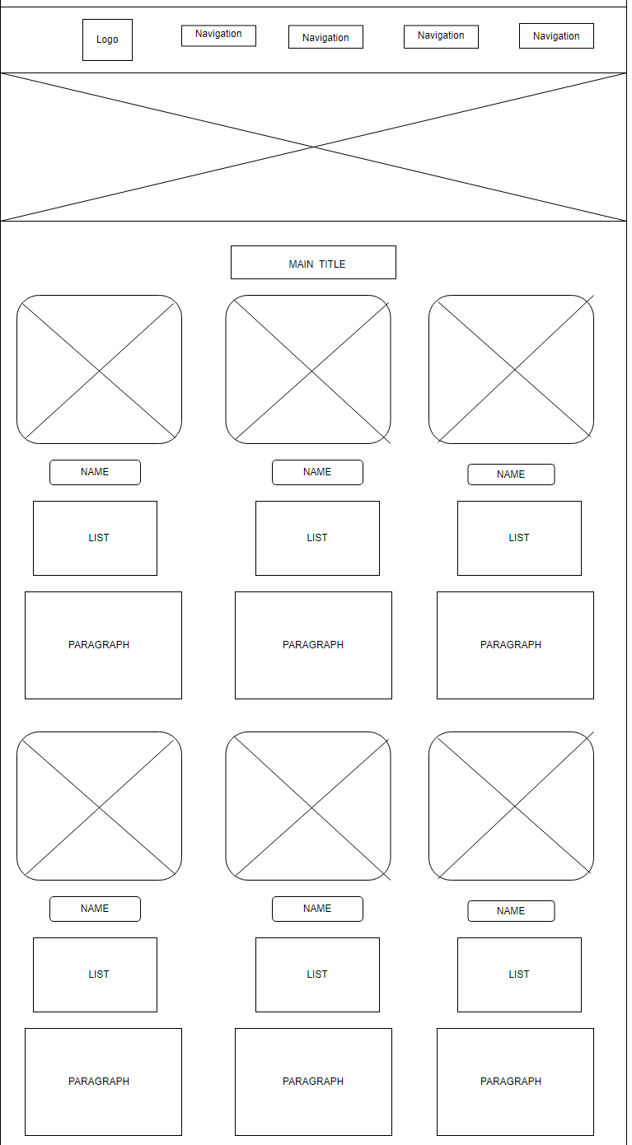

PAGE 5

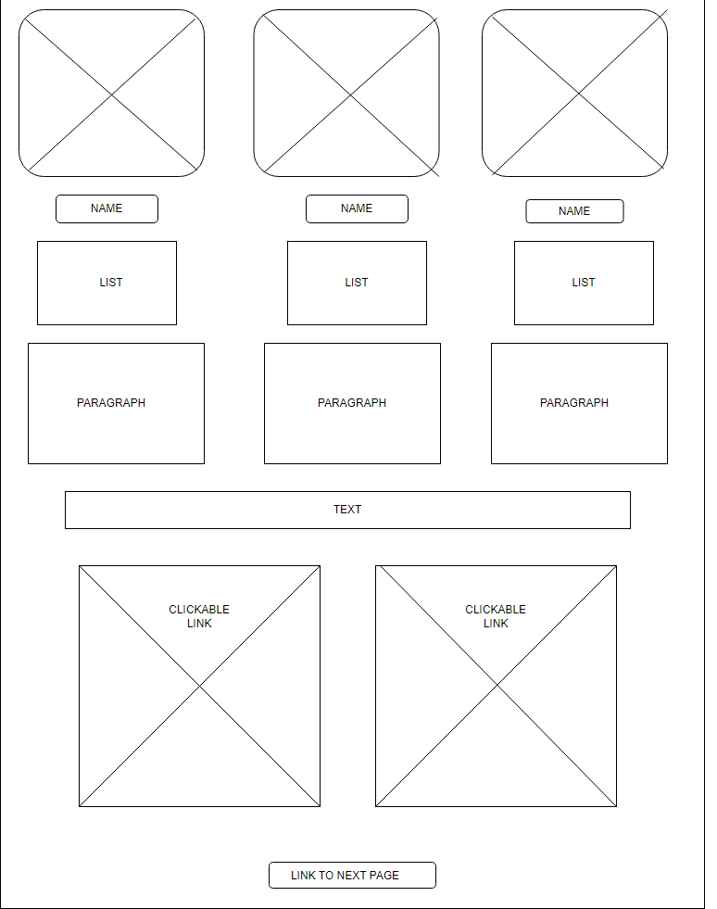

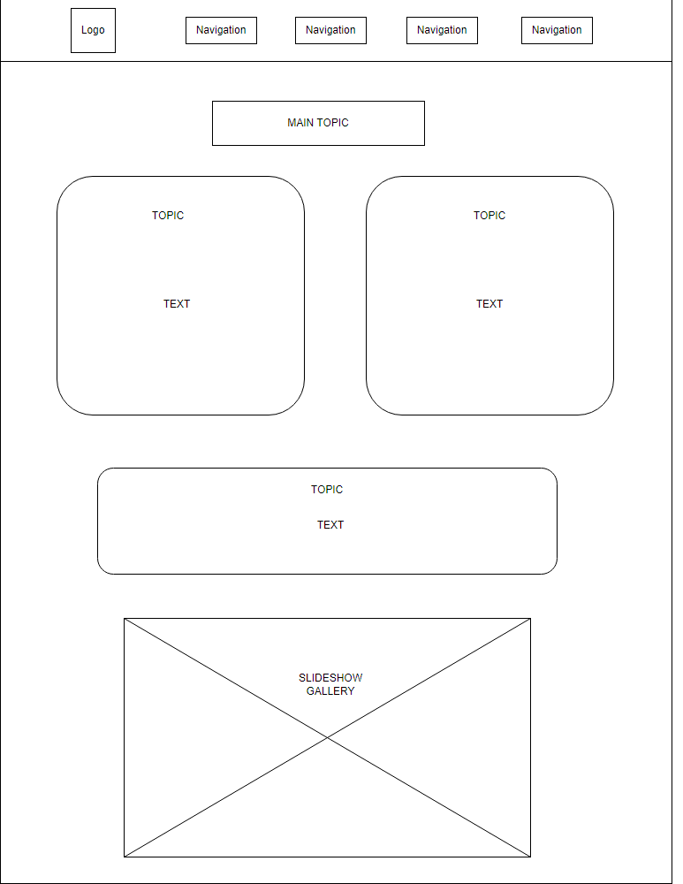

PAGE 6 (YALA)

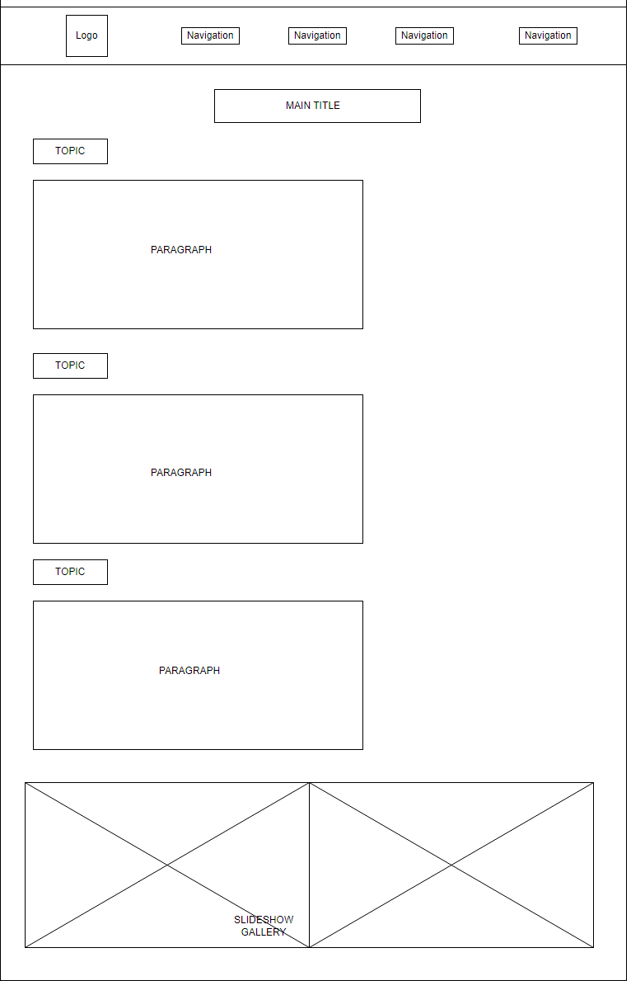

PAGE 7 (WILATTU)

**WIREFRAMES-MOBILE DESIGN**

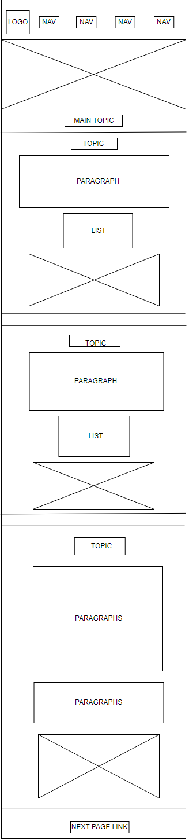

PAGE 1

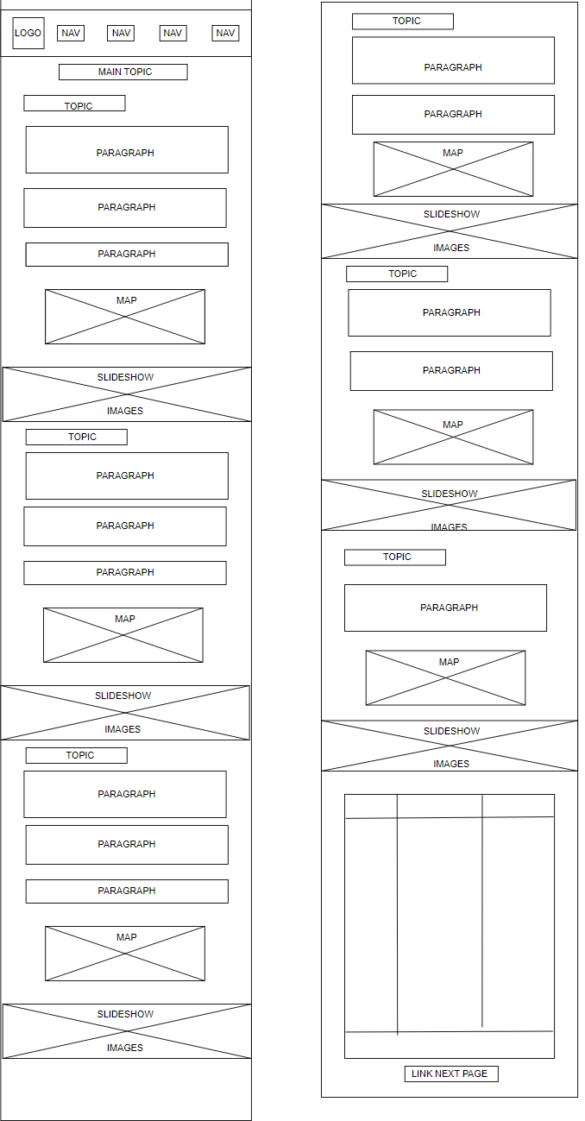

PAGE 2

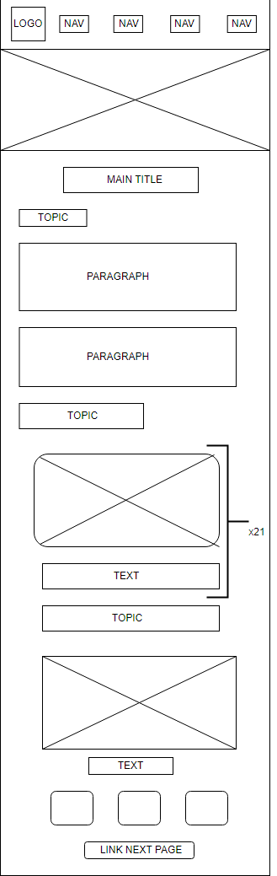

PAGE 3

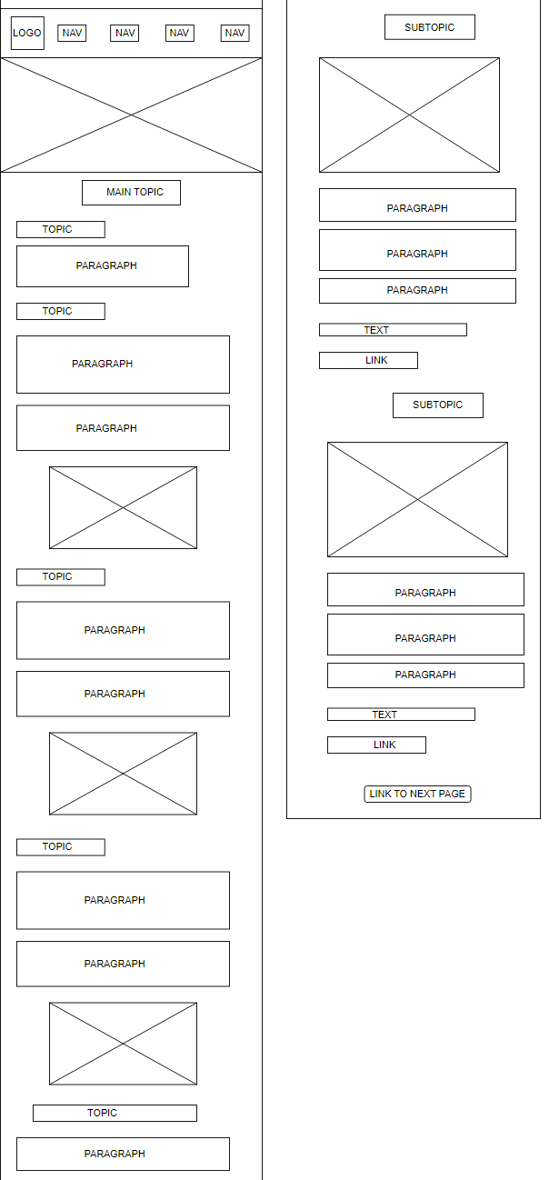

PAGE 4

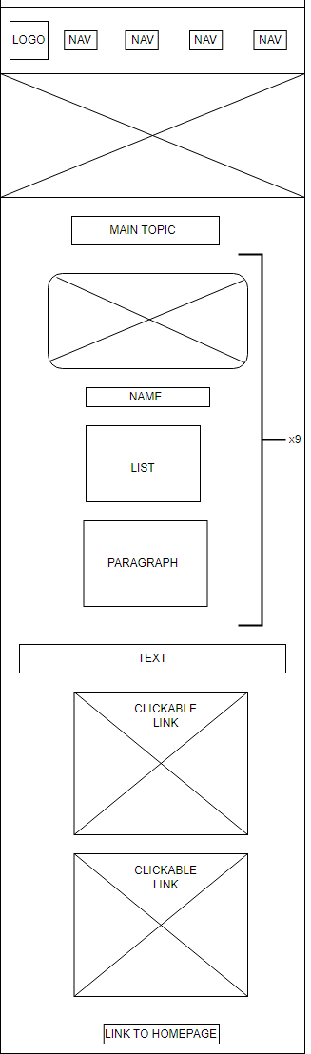

PAGE 5

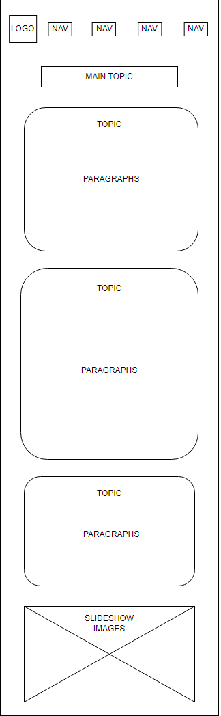

PAGE 6 (YALA)

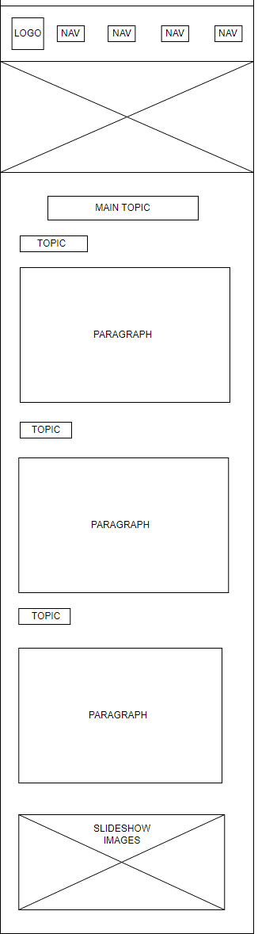

PAGE 7 (WILPATTU)